

NSS UNIT
DR. BABASAHEB AMBEDKAR JAYANTI
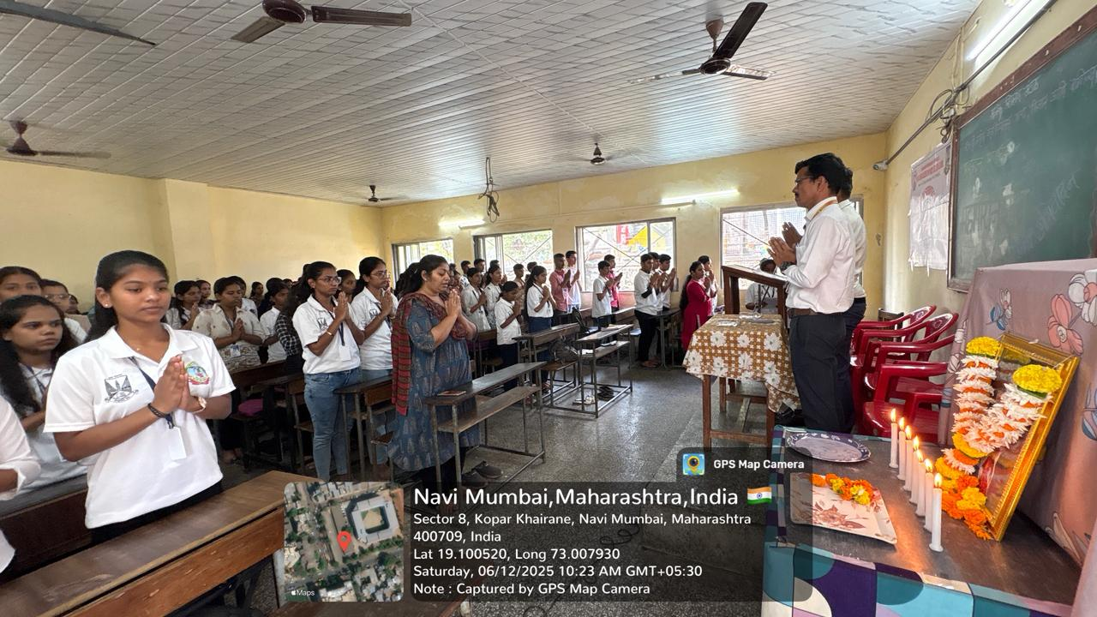

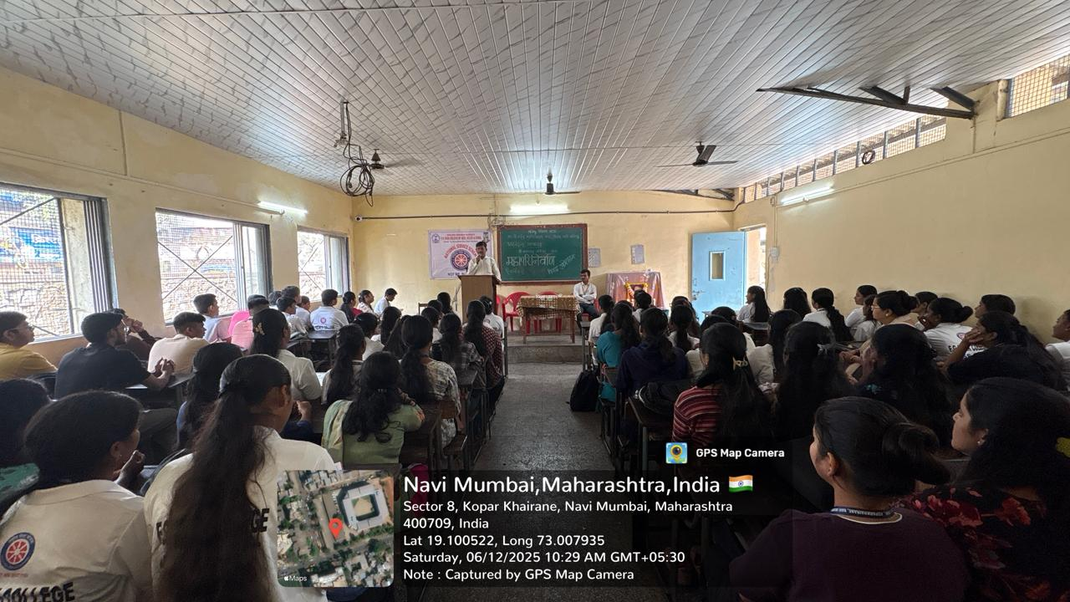
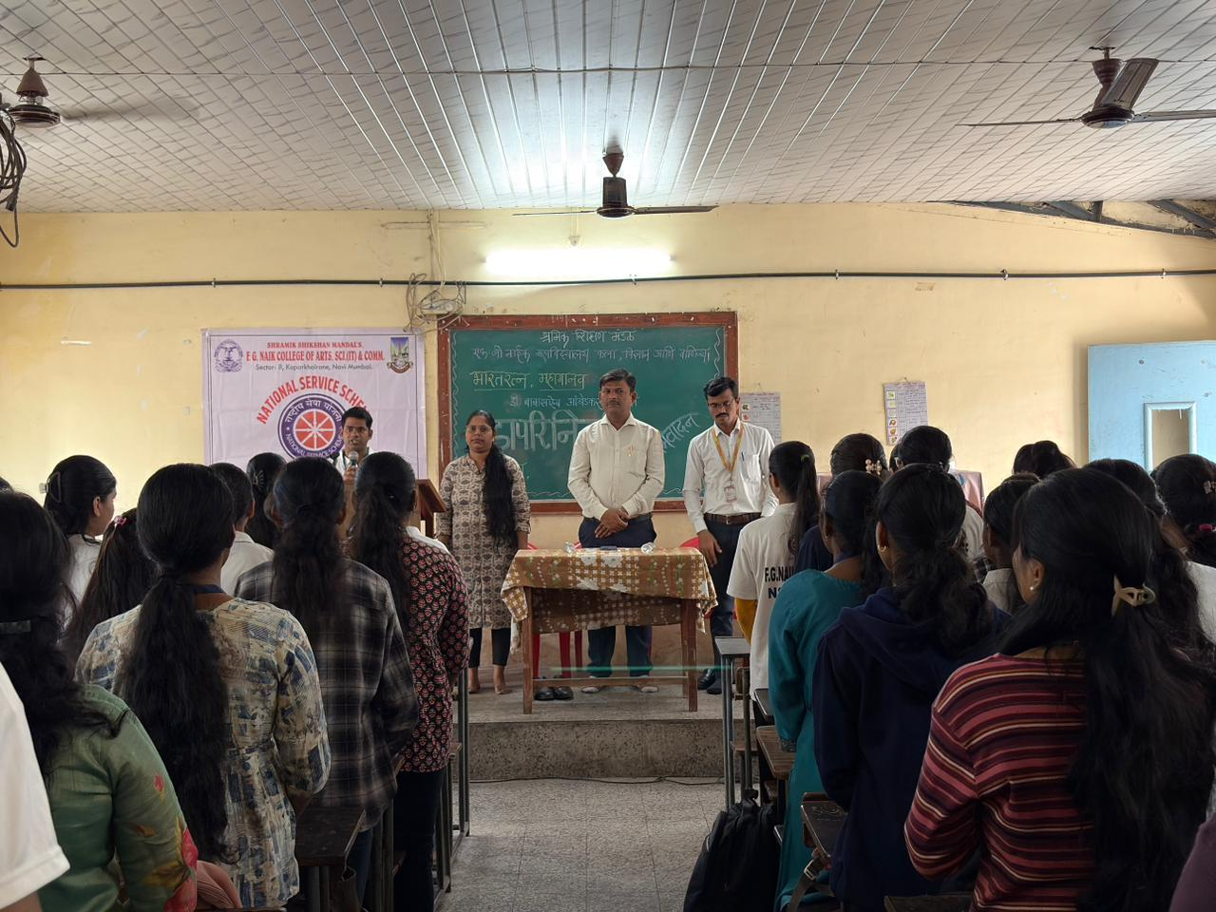

OBJECTIVE OF PROGRAM: To commemorate the birth anniversary of Dr. Babasaheb Ambedkar and to spread awareness about his contributions to the Indian Constitution, social justice, equality, and nation building.
DATE: 06/12/2025
LOCATION: F.G Naik College
PARTICIPATING STAFF: All the NSS volunteers, teaching and the non-teaching staff of the college.
NUMBER OF VOLUNTEERS PARTICIPATING: 24
The NSS Unit organized Dr. Babasaheb Ambedkar Jayanti to honor the life and work of Dr. B. R. Ambedkar. The program highlighted his role as the chief architect of the Indian Constitution and his relentless efforts towards the upliftment of the marginalized sections of society. Students were informed about his ideals of equality, education, and social reform.
The program inspired students to follow the principles of justice, liberty, equality, and fraternity as envisioned by Dr. Ambedkar. It helped in fostering respect for constitutional values and social responsibility among students.
PROGRAM DETAILS: The program commenced with a formal gathering, creating a respectful and reflective atmosphere.
The NSS Unit successfully conducted Dr. Babasaheb Ambedkar Jayanti, emphasizing his enduring legacy and relevance in building an inclusive and democratic society.

NSS IQAC
PROGRAM OFFICER CO-ORRDINATOR I/C PRINCIPAL

